Dated: 21 September 2006

To Whom It May Concern

This is to certify that Mr. Akash Ranjan is an employee of Ubika Corporation as a “Sales Support Engineer” in India.

Ubika Corporation is a Canadian company located at 34-2088 Mississauga, Ontario, Canada L5K 2S7, and provides professional services and outsourcing solutions to companies in Canada. It also specializes in providing Canadian companies strategic business development consulting and operation support in Indian market.

This is to certify that Mr. Akash Ranjan’s resides at the following address:
A-102, Paras Villa
Sector 50, Nerul West
Navi Mumbai, 400706, India.

If there is any further question, please do not hesitate to contact the undersigned at 416-729-1363.

Sincerely,

For Ubika Corporation.

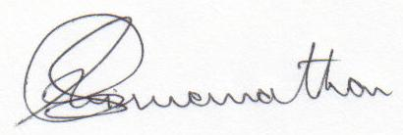

Vishy Karamadam
Director,
Ubika Corporation
34-2088 Leanne Blvd.
Ontario, Canada.
L5K 2S7

