

CYBERSHALA.COM
SINGAPORE PRIMARY MATHEMATICS
PLACEMENT TEST 1B

Name : ___________________ Marks: ____/100

Date : ____________

Section A
For Questions 1-20, choose the correct answer and write its number in the brackets ( ) provided. Each question carries 2 marks.

1 There are tens in forty.

(1) 1
(2) 2
(3) 3
(4) 4 ( )

2. 30 + 7 is equal to .

(1) 7
(2) 10
(3) 30
(4) 37 ( )

3. 2 tens is more than 15.

(1) 5
(2) 13
(3) 17
(4) 35 ( )

4. 39 is between 38 and .

(1) 37
(2) 38
(3) 39
(4) 40 ( )

5. Complete the number pattern.

20, 25, , 35, 40

(1) 26
(2) 27
(3) 30
(4) 34 ( )

6. 3 tens + 2 ones = .

(1) 5
(2) 15
(3) 23
(4) 32 ( )

7. 36 – 5 = .

(1) 5
(2) 21
(3) 31
(4) 41 ( )

8. Complete the number bond.

25
6
?

(1) 14
(2) 19
(3) 31
(4) 85 ( )

9. Complete the number bond

32
17

(1) 49
(2) 39
(3) 25
(4) 15 ( )

10. Find the sum of the greatest number and the smallest number in this set of numbers.

27 9 3 7

(1) 30
(2) 34
(3) 36
(4) 37 ( )

11. 48 - = 24

(1) 14
(2) 24
(3) 36
(4) 44 ( )

12. 20 + 4 = 12 + .

(1) 8
(2) 12
(3) 16
(4) 24 ( )

13. 46 is more than 28 by .

(1) 18
(2) 28
(3) 62
(4) 74 ( )

14. 7 twos =

(1) 7+7
(2) 7x7
(3) 2+2
(4) 2+2+2+2+2+2+2 ( )

15. 5 x 3 = 3 + 3 + 3 + 3 +

(1) 3
(2) 9
(3) 12
(4) 15 ( )

16. 2tens 5ones less than 72 is _________ .

(1) 22
(2) 47
(3) 57
(4) 70 ( )

17. 5 girls shared 20 stickers equally. Each girl got stickers.

(1) 3
(2) 4
(3) 5
(4) 6 ( )

18. What is the missing sign in the box?

27 = 9 3

(1) +
(2) -
(3) ÷
(4) x ( )

19. Which clock shows the time 4.30pm?
(1)
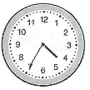
(2)
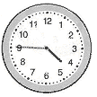

(3)
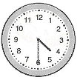
(4)
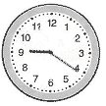 ( )

20. What is the difference between 82 and 35? .

(1) 47
(2) 53
(3) 55
(4) 57 ( )

Section B
For Questions 21 – 40, write the answers on the blanks provided. Each question carries 2 marks.

21. What is the missing number in the shaded part of the circle?

15

22. Write a number sentence for this picture.

×
=

23. Is half of the shape shaded? Circle Yes or No.

Yes / No

24. Tick the shape that is divided into half.

( ) ( ) ( )

25. There are quarters in half.

26. What is the next pattern? Circle it.

Write the time shown on each clock.

27. I get up at in the morning.

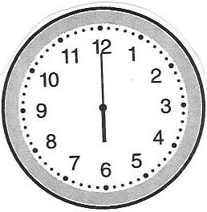

28. Mother reads me a story at every morning.

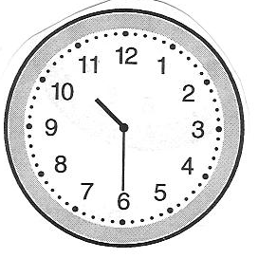

29. I go to bed at every night.

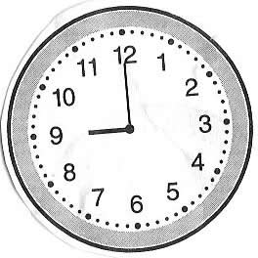

Study the graph below carefully and answer questions 30 and 31.

Animals in a pet shop
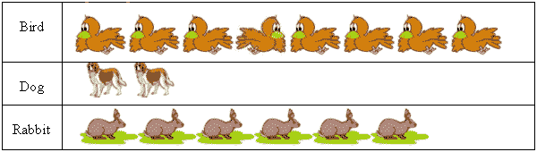

30. There are more birds than rabbits.

31. There are fewer dogs than rabbits.

32. Write 87 in words.

33. Fill in the missing numbers.

50, 60, , 80, , 100

34. The number just before 5tens 6ones is .

35. What is the sum of 45 and 52? .

36. What is the missing number?
50

65

37. 50 cents + 30 cents = cents.

38. How many $5 bills make up $25? .

39. The cap and the shirt are cheaper than the book.

Shirt

book
$24
$9
cap
$7

40. Peter had 65 stamps. He used 15 stamps and gave 8 stamps to his brother.
How many stamps had he left?

Section C (20 marks)

Questions 41 to 45 carry 4 marks each. For each of the following problem sum, show your work clearly in the space provided.

41. Jane made 25 tarts. Susie made 15 more tarts than Jane. How many tarts did
Susie make?

Susie made tarts.

42. Shawn has 57 sweets. His brother has 19 fewer sweets than him. How many
sweets does his brother have?

His brother has sweets.

43. There are 43 girls and 17 boys in the school hall. How many students are
there in the school hall?

There are students in the school hall.

44. 32 birds are flying. 19 of them stop to rest on a tree. How many birds are still
flying?

birds are still flying.

45. Sally bought 17 apples on Monday and 34 apples on Tuesday. How many
more apples did Sally buy on Tuesday than on Monday?

Sally bought more apples on Tuesday.

End of Paper

Placement Test for Singapore Primary Mathematics 1B

Answer Key

1) 4 21) 5 39) $8

2) 4 22) 5 × 4 = 20 40) 42

3) 1 23) No 41) 40

4) 4 24) 42) 38

5) 3 43) 60

6) 4 25) 2 44) 13

7) 3 26) 45) 17

8) 3

9) 4 27) 6 o’clock / 6.00

10) 1 28) half past ten / 10.30

11) 2 29) 9 o’clock / 9.00

12) 2 30) 2

13) 1 31) 4

14) 4 32) eighty-seven

15) 1 33) 70, 90

16) 2 34) 55

17) 2 35) 97

18) 4 36) 15

19) 3 37) 80

20) 1 38) 5

